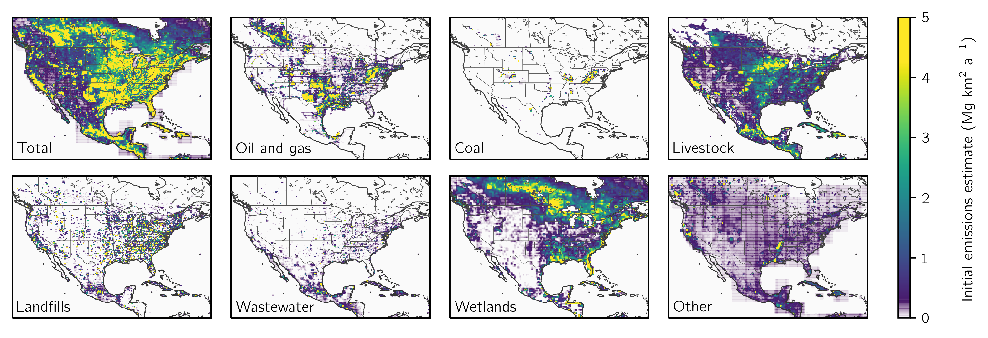

**Figure 1:** Prior emission estimates for the inversion. Panels show 2019 mean methane emissions of oil and gas, coal, livestock, landfills, wastewater, wetlands, and other sources from the gridded versions of the inventories reported by Canada (ECCC), the U.S. (EPA GHGI), and Mexico (INECC) to the UNFCCC under the Paris Agreement. Emissions are shown on the 0.25° ⨉ 0.3125° GEOS-Chem grid used for the inversion.

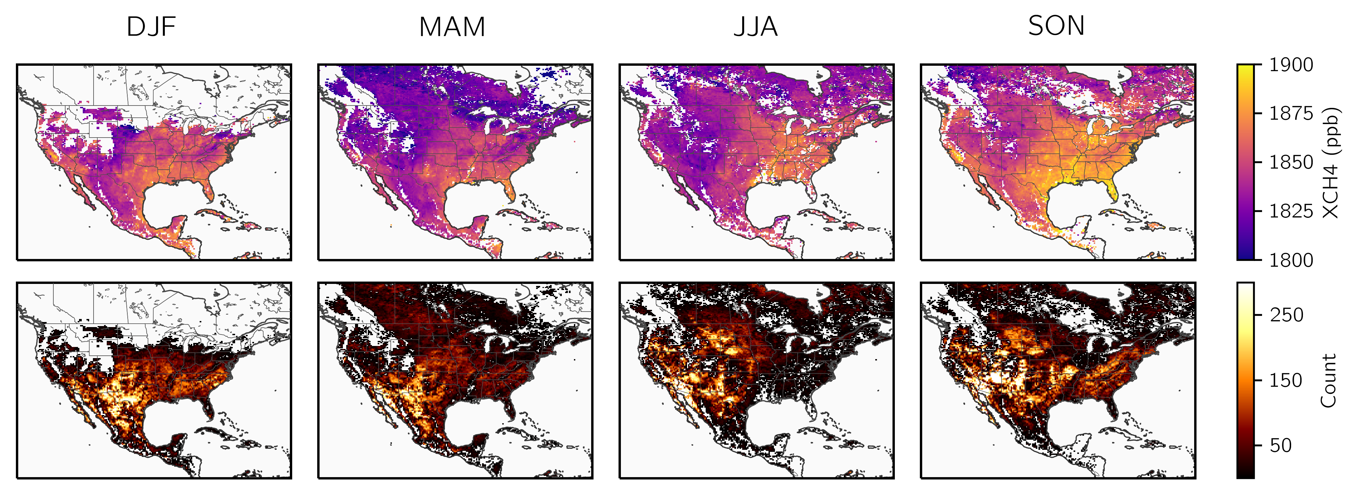

**Figure 2:** TROPOMI methane observations in 2019. The top row shows the seasonal average column dry methane mixing ratios (XCH4) averaged on the 0.25° ⨉ 0.3125° GEOS-Chem. The bottom row shows the observational density on the same grid. The observations have been filtered as described in section 2.4.

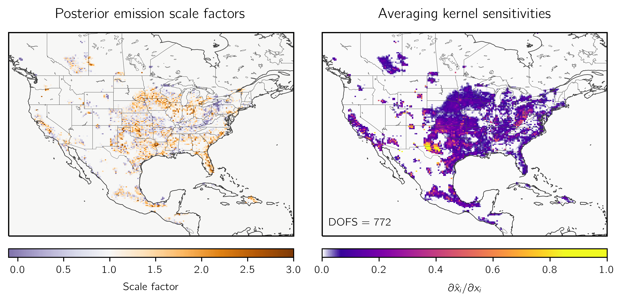

**Figure 3:** Optimization of 2019 methane emissions by inversion of TROPOMI observations. The left panel shows the correction factors relative to the gridded versions of the national emissions inventories for Canada (ECCC), the U.S. (EPA GHGI), and Mexico (INECC) used as the prior estimate for the inversion. The right panel shows the observing system information content as measured by the averaging kernel sensitivities (the diagonal elements of the averaging kernel matrix). Values of 1 indicate that TROPOMI fully constrains emissions, while values of 0 indicate full reliance on prior. The sum of these values gives the degrees of freedom for signal (DOFS), shown inset, which defines the number of pieces of information independently quantified by the observing system.

**Figure 4:** Optimization of 2019 sectoral methane emissions in the contiguous United States (CONUS) by TROPOMI observations. National prior (top bar) and posterior (bottom bar) emissions are shown for livestock, oil and gas, coal, landfills, wastewater, other anthropogenic emissions, and wetlands. The dark shading corresponds to emissions that occur in grid cells where the observing system provides a constraint (averaging kernel sensitivities greater than 0.05), while the light shading represents emissions occurring in the remaining grid cells. Error bars on the posterior emissions are given by the spread of an eight-member inversion ensemble.

**Figure 5:** Anthropogenic methane emissions for the 29 states in the contiguous United States (CONUS) responsible for 90% of optimized emissions. The bottom panel shows prior (left bar) and optimized (right bar) anthropogenic methane emissions divided by sector, including livestock, oil and natural gas, coal, landfill, wastewater, and other sources. States are listed from largest (left) to smallest (right) posterior emissions. The information content as defined by the reduced-form averaging kernel sensitivities (the diagonal elements of the reduced-form averaging kernel matrix; section 2.8) is shown in the bottom panel. In both cases, the error bars give the spread of an eight-member inversion ensemble.

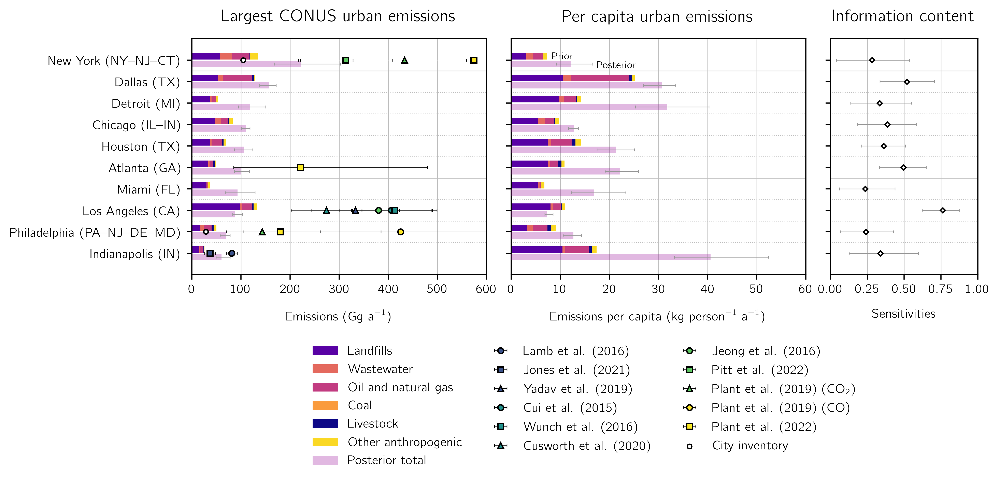

**Figure 6:** Anthropogenic methane emissions for the largest 10 methane-producing urban areas in the contiguous United States (CONUS). Urban area extents are given by the U.S. Census Bureau TIGER/Line files. The top bar shows prior emissions from the gridded EPA inventory and the bottom bar shows optimized total anthropogenic emissions (left panel) and per capita emissions (center panel). Prior emissions are divided into contributions from landfills, wastewater, oil and natural gas, coal, livestock, and other. We do not separate the posterior emissions due to source colocation within urban areas. Error bars represent the spread of an eight-member inversion ensemble. The right panel gives the information content, defined by the reduced-form averaging kernel sensitivities (the diagonal elements of the reduced-form averaging kernel matrix; section 2.8). We show independent urban emissions estimates and inventory values where available.

**Figure 7:** Livestock (TBD)

**Table 1:** The 8 members of the inversion ensemble.

|  |  |  |  |  |
| --- | --- | --- | --- | --- |
| **Optimized boundary conditions**1 | **Latitude correction**2 | **Regularization factor**3 | **Prior error standard deviation**3 | **Optimized grid cells**4 |
| Yes | Yes | 0.2 | 0.5 | 3692 |
| 0.45 | 0.75 | 5661 |
| Yes | No | 0.175 | 0.5 | 3435 |
| 0.3 | 0.75 | 5327 |
| 0.5 | 1 | 6067 |
| No | Yes | 0.175 | 0.5 | 3443 |
| 0.35 | 0.75 | 5476 |
| No | No | 0.175 | 0.75 | 4759 |

We conduct inversions that do and do not optimize the boundary conditions. In inversions with optimized boundary conditions, we include in the inversion state vector four boundary condition elements corresponding to the northern, eastern, southern, and western borders of the North American domain.

2 We also conduct inversions that do and do not correct the latitudinal bias in the model – observation difference with a first order polynomial. In inversions without a latitudinal correction, we remove the mean model – observation difference.

3 We balance the prior and observing system errors to avoid overfitting the emissions to the observations. The regularization factor $γ$ is applied to the inverse observational error covariance matrix $S_{O}^{-1}$ so that values less than one increase the observing system errors. The prior error standard deviation is assumed constant for all grid cells. We choose the values of the regularization factor and the prior error standard deviation following the chi-squared method described in section 2.7.

4 The number of grid cells optimized by the inversion, defined as the number of grid cells with sensitivity of the emissions to the observations greater than 0.05.

**Table 2:** 2019 methane emissions for the contiguous United States (CONUS).

|  |  |  |  |
| --- | --- | --- | --- |
|  | **Prior emissions**1 | **Posterior**  **emissions**2 | **Sensitivity**3 |
| **Total sources [Tg a-1]** | 36.5 | 39.3 (38.2 - 40.3) |  |
| **Anthropogenic sources** | 28.7 | 30.9 (30.0 - 31.8) |  |
| Livestock | 9.2 | 10.4 (10.0 - 10.7) | 0.66 (0.55 - 0.76) |
| Oil and natural gas | 9.4 | 10.4 (10.1 - 10.7) | 0.91 (0.88 - 0.95) |
| Coal | 2.9 | 1.5 (1.2 - 1.9) | 0.60 (0.45 - 0.80) |
| Landfills | 5.7 | 6.9 (6.4 - 7.5) | 0.47 (0.34 - 0.64) |
| Wastewater | 0.6 | 0.6 (0.5 - 0.7) | 0.33 (0.16 - 0.60) |
| Other anthropogenic | 0.9 | 1.1 (1.0 - 1.2) | 0.59 (0.44 - 0.76) |
| **Natural sources** | 7.8 | 8.4 (8.1 - 8.6) |  |
| Wetlands | 6.6 | 7.2 (7.0 - 7.4) | 0.35 (0.16 - 0.55) |
| Other biogenic | 1.1 | 1.2 (1.2 - 1.2) | 0.25 (0.19 - 0.32) |

1Prior emissions estimates for the inversion. Anthropogenic emissions are given by the gridded version of the Environmental Protection Agency (EPA) Inventory of U.S. Greenhouse Gas Emissions and Sinks (GHGI) for 2012. Oil and natural gas emissions are updated to match 2018 infrastructure and 2018 emissions as reported by the 2020 GHGI for 2018. Wetland emissions are provided a modified version of the high performance WetCHARTs ensemble version 1.3.1. Other biogenic emissions are as described by Lu et al. (2022).

2Optimized emissions from the inversion of TROPOMI data, with the range from the eight members of the inversion ensemble shown in parentheses.

3The sensitivity of the posterior emissions to the observing systems as given by the diagonal elements of the sectoral averaging kernel matrix calculated as described in section 2.8. The parenthetical values give the range of the inversion ensemble. Values range from 0 (no sensitivity) to 1 (full sensitivity)

**Table S1:** 2019 methane emissions from the 48 states in the contiguous United States.

|  |  |  |  |  |  |  |  |  |  |  |  |  |  |  |  |
| --- | --- | --- | --- | --- | --- | --- | --- | --- | --- | --- | --- | --- | --- | --- | --- |
| **Emissions**  **(Gg a-1)**1 | **Livestock** | | **Oil and natural gas** | | **Coal** | | **Landfills** | | **Wastewater** | | **Other anthropogenic** | | **Total anthropogenic** | | |
| **State** | **x**A2 | **x̂**3 | **x**A | **x̂** | **x**A | **x̂** | **x**A | **x̂** | **x**A | **x̂** | **x**A | **x̂** | **x**A | **x̂**4 | **Sensitivity**5 |
| 1. Texas | 977 | 1165 | 3546 | 4299 | 17 | 24 | 480 | 627 | 44 | 48 | 85 | 110 | 5150 | 6274 (6101, 6454) | 0.94 (0.89, 0.97) |
| 2. California | 877 | 1104 | 191 | 231 | 0 | 0 | 508 | 514 | 51 | 58 | 138 | 148 | 1764 | 2055 (1970, 2122) | 0.86 (0.75, 0.93) |
| 3. Oklahoma | 333 | 399 | 636 | 894 | 13 | 20 | 108 | 121 | 3 | 3 | 6 | 6 | 1099 | 1444 (1384, 1511) | 0.86 (0.75, 0.92) |
| 4. Pennsylvania | 165 | 196 | 409 | 238 | 461 | 524 | 131 | 196 | 16 | 20 | 16 | 20 | 1197 | 1194 (1061, 1384) | 0.57 (0.35, 0.77) |
| 5. New Mexico | 213 | 211 | 946 | 925 | 39 | 32 | 64 | -34 | 2 | 2 | 4 | 3 | 1267 | 1139 (1100, 1180) | 0.96 (0.93, 0.98) |
| 6. Louisiana | 63 | 79 | 431 | 731 | 2 | 2 | 104 | 126 | 7 | 9 | 114 | 174 | 721 | 1121 (1010, 1258) | 0.55 (0.28, 0.76) |
| 7. Iowa | 621 | 793 | 37 | 59 | 0 | 0 | 72 | 116 | 8 | 13 | 5 | 7 | 743 | 989 (952, 1010) | 0.75 (0.54, 0.88) |
| 8. Illinois | 153 | 191 | 87 | 121 | 209 | 170 | 237 | 368 | 28 | 37 | 17 | 21 | 731 | 907 (862, 944) | 0.55 (0.29, 0.79) |
| 9. Florida | 164 | 250 | 18 | 26 | 0 | 0 | 297 | 540 | 11 | 15 | 30 | 47 | 521 | 878 (699, 1106) | 0.32 (0.04, 0.58) |
| 10. Kansas | 440 | 448 | 338 | 358 | 0 | 0 | 84 | 41 | 11 | 9 | 4 | 3 | 878 | 860 (839, 888) | 0.80 (0.66, 0.89) |
| 11. Colorado | 255 | 232 | 376 | 351 | 176 | 102 | 113 | 110 | 4 | 4 | 6 | 5 | 930 | 804 (740, 861) | 0.59 (0.44, 0.72) |
| 12. Michigan | 160 | 187 | 113 | 121 | 0 | 0 | 268 | 392 | 11 | 19 | 16 | 22 | 568 | 742 (674, 813) | 0.49 (0.16, 0.74) |
| 13. Alabama | 102 | 109 | 113 | 120 | 165 | 154 | 238 | 259 | 21 | 25 | 10 | 11 | 649 | 677 (629, 717) | 0.75 (0.55, 0.89) |
| 14. North Carolina | 252 | 375 | 24 | 23 | 0 | 0 | 183 | 225 | 123 | 17 | 11 | 13 | 593 | 654 (547, 744) | 0.48 (0.24, 0.71) |
| 15. Ohio | 143 | 146 | 195 | 160 | 94 | 32 | 252 | 244 | 22 | 24 | 16 | 16 | 723 | 622 (578, 673) | 0.63 (0.38, 0.82) |
| 16. Indiana | 127 | 170 | 45 | 60 | 82 | 79 | 163 | 274 | 10 | 17 | 11 | 16 | 438 | 616 (561, 676) | 0.54 (0.28, 0.74) |
| 17. Nebraska | 480 | 533 | 22 | 24 | 0 | 0 | 41 | 46 | 5 | 5 | 3 | 3 | 551 | 611 (604, 619) | 0.64 (0.48, 0.73) |
| 18. West Virginia | 31 | 26 | 240 | 182 | 816 | 360 | 49 | 32 | 2 | 2 | 6 | 4 | 1143 | 607 (485, 730) | 0.66 (0.46, 0.83) |
| 19. Arkansas | 124 | 122 | 105 | 134 | 9 | 13 | 93 | 106 | 8 | 10 | 189 | 218 | 527 | 605 (569, 636) | 0.74 (0.48, 0.86) |
| 20. Georgia | 109 | 127 | 32 | 47 | 0 | 0 | 218 | 374 | 5 | 9 | 12 | 18 | 376 | 575 (509, 655) | 0.58 (0.35, 0.73) |
| 21. Wisconsin | 380 | 407 | 15 | 16 | 0 | 0 | 103 | 114 | 9 | 8 | 13 | 14 | 519 | 559 (518, 595) | 0.47 (0.07, 0.70) |
| 22. Idaho | 319 | 317 | 10 | 11 | 0 | 0 | 165 | 219 | 1 | 2 | 3 | 3 | 499 | 551 (498, 596) | 0.63 (0.49, 0.76) |
| 23. Minnesota | 291 | 381 | 30 | 26 | 0 | 0 | 76 | 83 | 4 | 4 | 9 | 10 | 410 | 504 (475, 534) | 0.53 (0.13, 0.69) |
| 24. Mississippi | 86 | 104 | 97 | 132 | 3 | 6 | 87 | 134 | 16 | 24 | 17 | 23 | 307 | 423 (380, 478) | 0.53 (0.22, 0.75) |
| 25. New York | 170 | 139 | 84 | 47 | 0 | 0 | 140 | 154 | 35 | 43 | 19 | 23 | 448 | 405 (352, 445) | 0.30 (0.06, 0.50) |

|  |  |  |  |  |  |  |  |  |  |  |  |  |  |  |  |
| --- | --- | --- | --- | --- | --- | --- | --- | --- | --- | --- | --- | --- | --- | --- | --- |
| **Emissions**  **(Gg a-1)**1 | **Livestock** | | **Oil and natural gas** | | **Coal** | | **Landfills** | | **Wastewater** | | **Other anthropogenic** | | **Total anthropogenic** | | |
| **State** | **x**A2 | **x̂**3 | **x**A | **x̂** | **x**A | **x̂** | **x**A | **x̂** | **x**A | **x̂** | **x**A | **x̂** | **x**A | **x̂**4 | **Sensitivity**5 |
| 26. Kentucky | 152 | 143 | 92 | 68 | 202 | 69 | 108 | 105 | 4 | 4 | 7 | 7 | 566 | 395 (347, 449) | 0.64 (0.40, 0.82) |
| 27. South Dakota | 292 | 347 | 9 | 12 | 0 | 0 | 13 | 18 | 5 | 12 | 2 | 2 | 322 | 392 (376, 401) | 0.38 (0.11, 0.53) |
| 28. Missouri | 292 | 266 | 16 | 14 | 0 | 0 | 82 | 54 | 10 | 9 | 39 | 24 | 439 | 367 (339, 394) | 0.55 (0.29, 0.69) |
| 29. Virginia | 112 | 109 | 61 | 31 | 172 | 20 | 171 | 169 | 23 | 22 | 12 | 11 | 550 | 362 (299, 428) | 0.56 (0.35, 0.75) |
| 30. Tennessee | 136 | 122 | 38 | 40 | 3 | 2 | 156 | 132 | 23 | 20 | 8 | 7 | 364 | 322 (301, 349) | 0.60 (0.33, 0.77) |
| 31. Montana | 212 | 211 | 70 | 63 | 20 | 10 | 19 | 19 | 1 | 1 | 3 | 3 | 323 | 306 (292, 322) | 0.31 (0.22, 0.40) |
| 32. North Dakota | 123 | 124 | 137 | 141 | 6 | 6 | 25 | 26 | 2 | 2 | 2 | 2 | 294 | 300 (286, 317) | 0.59 (0.41, 0.70) |
| 33. Washington | 143 | 149 | 20 | 20 | 0 | 0 | 84 | 98 | 13 | 14 | 13 | 13 | 273 | 293 (269, 337) | 0.10 (0.04, 0.14) |
| 34. Utah | 102 | 105 | 134 | 49 | 119 | 79 | 51 | 49 | 0 | 0 | 3 | 3 | 408 | 285 (248, 336) | 0.74 (0.57, 0.87) |
| 35. Oregon | 126 | 132 | 18 | 23 | 0 | 0 | 87 | 111 | 2 | 3 | 8 | 8 | 241 | 276 (256, 304) | 0.08 (0.05, 0.11) |
| 36. Arizona | 142 | 141 | 41 | 41 | 2 | 2 | 86 | 72 | 4 | 4 | 4 | 3 | 279 | 263 (261, 266) | 0.80 (0.74, 0.84) |
| 37. South Carolina | 42 | 53 | 9 | 11 | 0 | 0 | 102 | 145 | 16 | 21 | 6 | 8 | 175 | 237 (220, 249) | 0.51 (0.20, 0.70) |
| 38. New Jersey | 4 | 4 | 34 | 51 | 0 | 0 | 74 | 116 | 21 | 35 | 19 | 27 | 151 | 233 (186, 294) | 0.28 (0.06, 0.52) |
| 39. Maryland | 27 | 28 | 20 | 20 | 4 | 4 | 60 | 57 | 5 | 4 | 8 | 7 | 125 | 120 (112, 126) | 0.26 (0.04, 0.45) |
| 40. Nevada | 49 | 49 | 9 | 9 | 0 | 0 | 30 | 30 | 2 | 2 | 2 | 2 | 92 | 93 (93, 93) | 0.00 (0.00, 0.00) |
| 41. Massachusetts | 5 | 4 | 20 | 17 | 0 | 0 | 55 | 48 | 6 | 4 | 8 | 7 | 93 | 80 (66, 93) | 0.15 (0.00, 0.35) |
| 42. Wyoming | 116 | 113 | 230 | 142 | 281 | -186 | 12 | 10 | 0 | 0 | 2 | 1 | 641 | 80 (-194, 279) | 0.68 (0.48, 0.86) |
| 43. Vermont | 27 | 29 | 0 | 0 | 0 | 0 | 12 | 13 | 1 | 1 | 3 | 3 | 43 | 46 (45, 49) | 0.02 (0.00, 0.07) |
| 44. Connecticut | 6 | 5 | 9 | 8 | 0 | 0 | 16 | 15 | 15 | 12 | 5 | 4 | 51 | 45 (35, 51) | 0.26 (0.01, 0.50) |
| 45. Maine | 10 | 10 | 2 | 2 | 0 | 0 | 20 | 20 | 1 | 1 | 6 | 6 | 39 | 38 (37, 39) | 0.00 (0.00, 0.00) |
| 46. New Hampshire | 5 | 5 | 1 | 1 | 0 | 0 | 17 | 16 | 1 | 1 | 3 | 3 | 27 | 25 (23, 27) | 0.03 (0.00, 0.08) |
| 47. Delaware | 4 | 4 | 2 | 2 | 0 | 0 | 5 | 8 | 5 | 5 | 1 | 2 | 17 | 20 (19, 22) | 0.12 (0.04, 0.23) |
| 48. Rhode Island | 1 | 1 | 4 | 4 | 0 | 0 | 13 | 11 | 2 | 2 | 1 | 1 | 22 | 18 (14, 21) | 0.19 (0.07, 0.34) |

Sectoral emissions in gigagrams per year (Gg a-1) for anthropogenic emission sources, including livestock, oil and natural gas, landfillls, wastewater, and other categories, including rice.

2The prior emissions for each state from the gridded version of the Environmental Protection Agency (EPA) Inventory of U.S. Greenhouse Gas Emissions and Sinks (GHGI) for 2012. Oil and natural gas emissions are updated to match 2018 infrastructure and 2018 emissions as reported by the 2020 GHGI for 2018, except over the Permian basin in Texas where we use a high-resolution inventory from the Environmental Defense Fund.

3Optimized sectoral anthropogenic emissions from an inversion of TROPOMI data.

4The total anthropogenic optimized emissions. Values in parentheses give the minimum and maximum of an ensemble of 8 inversions.

5The sensitivity of the total state posterior emissions to the observing system, given by the diagonal elements of the state averaging kernel matrix calculated. Values in parentheses give the ensemble range. Sensitivities range from 0 (unresponsive to the observing system) to 1 (fully responsive).

**Table S2:** Top 10 methane-producing urban areas in the contiguous U.S. (CONUS) for 2019.

|  |  |  |  |  |  |  |  |  |
| --- | --- | --- | --- | --- | --- | --- | --- | --- |
| **Urban area**1 | **Prior emissions (Gg a-1)**2 | | | | | **Posterior emissions** | | |
| **Landfills** | **Wastewater** | **Oil and natural gas** | **Livestock** | **Other anthropogenic** | **Total (Gg a-1)** | **Per capita**  **(kg person-1 a-1)**4 | **Sensitivity**5 |
| New York-Newark, NY-NJ-CT | 57.24 | 24.33 | 35.90 | 0.68 | 15.72 | 222 (169, 302) | 12.10 | 0.28 (0.04, 0.54) |
| Dallas-Fort Worth-Arlington, TX | 53.78 | 8.99 | 59.82 | 3.37 | 2.78 | 157 (138, 172) | 30.80 | 0.52 (0.34, 0.70) |
| Detroit, MI | 36.26 | 4.04 | 8.93 | 0.53 | 3.63 | 119 (95, 150) | 31.80 | 0.33 (0.14, 0.55) |
| Chicago, IL--IN | 47.31 | 11.97 | 15.25 | 2.12 | 6.54 | 110 (101, 118) | 12.80 | 0.38 (0.18, 0.58) |
| Houston, TX | 36.86 | 3.51 | 20.72 | 3.55 | 5.37 | 106 (86, 124) | 21.30 | 0.36 (0.21, 0.51) |
| Atlanta, GA | 33.69 | 2.22 | 7.36 | 3.06 | 2.68 | 100 (86, 117) | 22.20 | 0.50 (0.33, 0.65) |
| Miami, FL | 29.75 | 2.04 | 1.55 | 0.41 | 3.54 | 93 (68, 128) | 16.90 | 0.24 (0.06, 0.44) |
| Los Angeles-Long Beach-Anaheim, CA | 97.40 | 5.68 | 19.18 | 3.24 | 7.57 | 89 (83, 103) | 7.30 | 0.76 (0.62, 0.88) |
| Philadelphia, PA-NJ-DE-MD | 17.54 | 6.39 | 16.25 | 4.01 | 5.73 | 69 (58, 78) | 12.70 | 0.24 (0.07, 0.43) |
| Indianapolis, IN | 15.54 | 0.86 | 7.09 | 0.91 | 1.49 | 60 (49, 78) | 40.60 | 0.34 (0.13, 0.60) |

The 10 urban areas with the largest optimized methane emissions. Urban area extents are given by the U.S. Census Bureau TIGER/Line files.

2The prior anthropogenic emissions for landfills, wastewater, oil and natural gas, livestock, and other sources for each urban area in gigagrams per year (Gg a-1) from the gridded version of the Environmental Protection Agency (EPA) Inventory of U.S. Greenhouse Gas Emissions and Sinks (GHGI) for 2012. Oil and natural gas emissions are updated to match 2018 infrastructure and 2018 emissions as reported by the 2020 GHGI for 2018. There are no coal emissions in these urban areas.

3Optimized emissions from inversion of TROPOMI observations in gigagrams per year. Values in parentheses represent the range from an eight-member inversion ensemble.

4Mean per capita methane emissions assuming 2010 Census populations in kilograms per person per year (kg-1 person-1 a-1).

5The sensitivity of an urban area to the satellite-model observing system as given by the diagonal elements of the urban averaging kernel matrix calculated as described in section 2.8. Values close to 1 indicate that the posterior emissions are fully sensitive to the observing system, while values close to 0 rely almost entirely on the prior estimate. Values in parentheses give the ensemble range.